PingFederate Integration Overview Document
Version 0.1

Introduction 3
Identity Federation 3
Identity Provider & Service Provider 4
PingFederate Overview 5
Integration with PingFederate 5
Security Assertion Markup Language (SAML) 9
Single Sign On with SAML 9
Browser/Artifact profile 9
Browser/POST profile 10
SP Initiated SSO 11
ASP Integration Overview 14
Conclusion 15

Introduction

Cisco presently uses CA Siteminder for Federation Services using the Siteminder 4.x Affiliate Agent or the SAML Agent. As a part of the enterprise objective to migrate off all CA products, and also in order to move to a more standards-based Federation Framework, it has been decided to migrate to Ping Identity Solution’s PingFederate. The purpose of this document is to provide the Application Service Providers (ASPs) for Cisco Systems, Inc. with an overview of the Integration capabilities of PingFederate as the new Identity Federation product throughout the enterprise.

Identity Federation

Identity federation (or “Federated identity management”) enables enterprises to securely exchange identity information across Internet domains. Federation also enables secure SSO between distinct business units within a single organization. As organizations grow through acquisitions, or when business units maintain their own user repositories and authentication mechanisms, a federated solution to secure SSO is desirable.

The following diagram illustrates the benefits of Identity Federation –

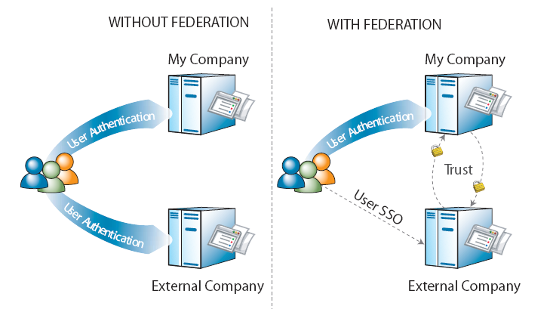

Identity Provider & Service Provider

Identity federation standards identify two operational roles in an Internet SSO transaction: the identity provider (IdP) and the service provider (SP). An IdP, for example, might be an enterprise that manages accounts for a large number of users who need secure Internet access to the Web-based applications or services of customers, suppliers, and business partners. An SP might be a Software-as-a-Service (SaaS) or a business-process outsourcing (BPO) vendor wanting to simplify client access to its services.

In Cisco’s Federation scenario, as well as in further references in this document,
- Cisco is the Identity Provider (IdP)
- the ASPs are the Service Providers (SPs)

Identity federation allows both types of organizations to define a trust relationship whereby the SP provides access to users from the IdP. The IdP continues to manage its users, and the SP trusts the IdP to authenticate them.

PingFederate Overview

PingFederate allows standards-based Internet SSO without the cost and complexity of deploying a complete identity management (IdM) system. The PingFederate server integrates and coexists with existing home-grown and commercial IdM systems.

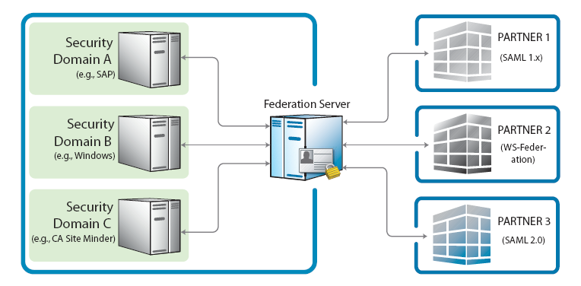

As a stand-alone server, PingFederate must be integrated programmatically with end-user applications and identity management (IdM) systems to complete the “first-and last-mile” implementation of a federated-identity network. The purpose of this document is to provide an overview of the various approaches to integrating applications with PingFederate. To enable both the Identity Provider (IdP) and Service Provider (SP) sides of this integration, PingFederate provides bundled and commercial integration kits, which include adapters that plug into the PingFederate server and agents that interface with local IdM systems or applications.

Integration with PingFederate

For an IdP, the first step in the integration process involves sending identity attributes from an authentication service or application to PingFederate. PingFederate uses those identity attributes to generate a SAML assertion. IdP integration typically provides a mechanism through which PingFederate can look up a user’s current authenticated session data (for example, a cookie) or authenticate a user without such a session.

For an SP, the last step of the integration process involves sending identity attributes from PingFederate to the target application. PingFederate extracts the identity attributes from the incoming SAML assertion and sends them to the target application to set a valid session cookie or other application-specific security context for the user.

- Identity Provider Integration
An IdP is a system entity that authenticates a user, or “SAML subject,” and transmits referential identity attributes based on that authentication to PingFederate. The IdP integration involves retrieving user-identity attributes from the IdP domain and sending them to the PingFederate server. Typically, the identity attributes are retrieved from an authenticated user session. For IdP integration, a number of attribute-retrieval approaches can be used, depending upon the IdP deployment/implementation environment.

Ping Identity comes with commercial integration kits that address various IdP scenarios, most of which involve either custom-application integration, integration with a commercial IdM product, or integration with an authentication system. The following are the common integration kits supported by PingFederate –

  - Custom Application – Java, .NET, PHP
  - Identity Management System – CA Siteminder, Oracle Access Manager, IBM Tivoli Access Manager
  - Authentication System – Integrated Windows Authentication (IWA), NTLM, LDAP Authentication Service

- Service Provider Integration

An SP is the consumer of identity attributes provided by the IdP through a SAML assertion. SP integration involves passing the identity attributes from PingFederate to the target SP application. The SP application uses this information to set a valid session or other security context for the user represented by the identity attributes.

Ping Identity comes with commercial integration kits that address various SP scenarios. Most SP scenarios involve custom-application integration, server-agent integration, integration with an IdM product, or integration with a commercial application. The following are the common integration kits supported by PingFederate –

  - Custom Application – Java, .NET, PHP
  - Server Agent – IIS, Apache, WebLogic, WebSphere, SAP NetWeaver
  - Identity Management System – CA Siteminder, Oracle Access Manager, IBM Tivoli Access Manager
  - Commercial Applications – Citrix, SharePoint, Salesforce.com

Security Assertion Markup Language (SAML)

The Security Assertion Markup Language (SAML) is a standard developed by the Organization for the Advancement of Structured Information Standards (OASIS). It is an industry standard that defines an XML framework for exchanging authentication and authorization information. PingFederate supports both the SAML 1.x and SAML 2.0 specifications.

SAML defines assertions as a means to pass security information about users between entities. SAML assertions are XML documents that contain information about a specific subject, such as a user. An assertion can contain several different internal statements about authentication, authorization, and attributes. For SAML specifications and background documentation, see http://www.oasis-open.org and select the document Security Services technical committee. For more information on SAML please see the OASIS documents at http://www.oasis-open.org/committees/security/docs.

Single Sign On with SAML

SAML defines two browser-based protocols that specify how SAML assertions are passed between partners to facilitate single sign-on. Additionally, SAML provides for an SP-initiated scenario which helps in creating applications that enable a user to initiate SSO from the SP site. These three scenarios are explained as under –

Browser/Artifact profile
In this scenario, the IdP sends a SAML artifact to the SP via either HTTP POST or a redirect (shown in diagram). The SP uses the artifact to obtain the associated SAML response from the IdP. This defines a SAML artifact as a reference to a SAML assertion.

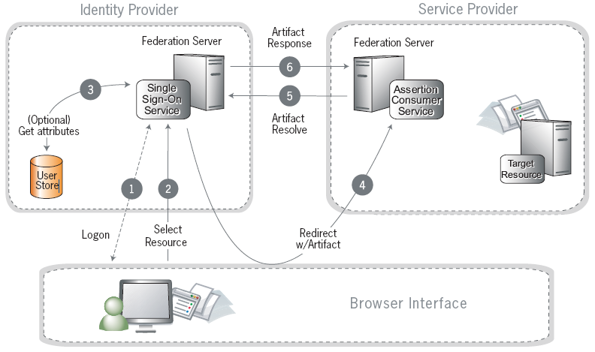

Steps –

- A user has logged on to the IdP
- The user requests access to a protected SP resource. The user is not logged on to the SP site.
- Optionally, the IdP retrieves attributes from the user data store.
- The IdP federation server generates an assertion, creates an artifact, and sends an HTTP redirect containing the artifact through the browser to the SP’s Assertion Consumer Service (ACS).
- The ACS extracts the Source ID from the SAML artifact and sends an artifact-resolve message to the identity federation server’s Artifact Resolution Service (ARS).
- The ARS sends a SAML artifact response message containing the previously generated assertion.
- If a valid assertion is received, the SP establishes a session and redirects the browser to the target resource.

Browser/POST profile
In this scenario, a user is logged on to the IdP and attempts to access a resource on a remote SP server. The SAML assertion is transported to the SP via HTTP POST. This returns a response that contains an assertion.

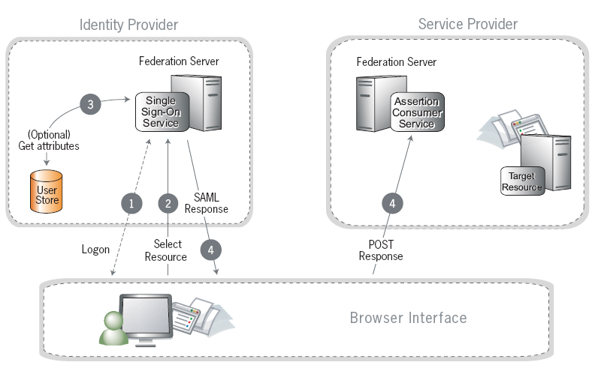

Steps –

- A user has logged on to the IdP
- The user requests access to a protected SP resource. The user is not logged on to the SP site.
- Optionally, the IdP retrieves attributes from the user data source.
- The IdP’s SSO service returns an HTML form to the browser with a SAML response containing the authentication assertion and any additional attributes. The browser automatically posts the HTML form back to the SP.
- If the signature and assertion are valid, the SP establishes a session for the user and redirects the browser to the target resource.

SP Initiated SSO

In an SP-initiated (a.k.a. “destination-first”) transaction the user is connected to an SP site and attempts to access a protected resource in the SP domain. The user might have an account at the SP site but according to federation agreement, authentication is managed by the IdP. The SP sends an authentication request to the IdP.

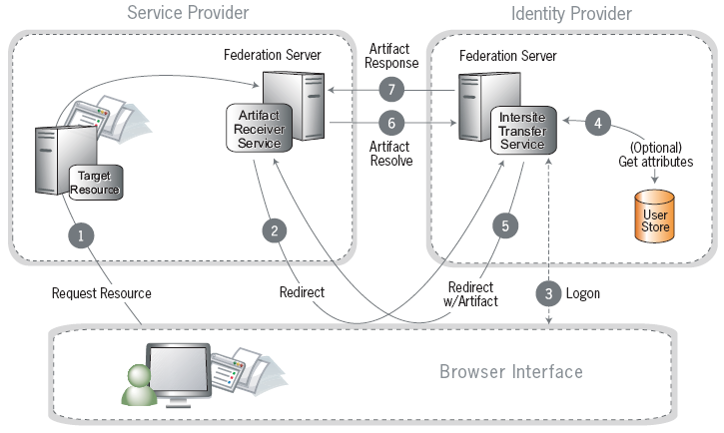

Steps –

- The user requests access to a protected SP resource. The request is redirected to the federation server to handle authentication.
- The federation server sends a SAML request for authentication to the IdP’s SSO service (also called the Intersite Transfer Service).
- If the user is not already logged on to the IdP site or if re-authentication is required, the IdP asks for credentials (e.g., ID and password) and the user logs on.
- Additional information about the user may be retrieved from the user data store for inclusion in the SAML response. These attributes are predetermined as part of the federation agreement between the IdP and the SP.
- The IdP’s Intersite Transfer Service returns an artifact, representing the SAML response, to the SP.
- The SP’s artifact handling service sends a SOAP request with the artifact to the IdP’s artifact resolver endpoint.
- The IdP resolves the artifact and returns the corresponding SAML response with the SSO assertion.
- If the assertion is valid, the SP establishes a session for the user and redirects the browser to the target resource.

ASP Integration Overview

The concepts and capabilities discussed in the earlier sections would facilitate the implementation of the Federated Solution between Cisco and the Service Providers (ASPs). The proposed high-level solution is as below –

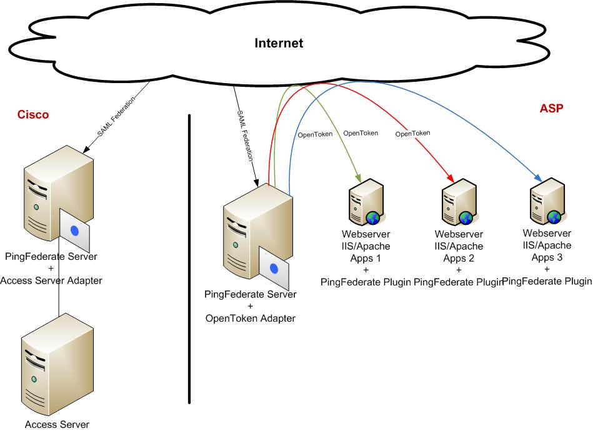

The integration process with PingFederate, from an ASP perspective involves the following –

- Installing and configuring the PingFederate bundle (SP) – Communicates with IdP and the ASP Web Server for the authentication. This can, in theory, reside on the same physical box as the ASP Web Server.
- Installing and configuring the Plug-in Adapter – Intercepts requests for the ASP resource and communicates with the PingFederate Bundle for assertions and sets the user attributes from SAML assertion in the HTTP Headers.

Note: The Adapter integrates with Apache or IIS – depending on the ASP architecture.

Conclusion

This document is not exhaustive – it just provides an overview of the PingFederate software and its capabilities. For detailed documentation, including installation and configuration information please refer to the PingFederate Installation & Configuration Guide.

